Image Tamper Detection Using Hanoi Based Block Mapping
Project report submitted in partial fulfillment of the requirement for the award of the Degree of B.Tech
By

Abdul Muzamil - 22241A0466

Gayatri Geethika A - 22241A0485 Shaik Afroz - 22241A04B9

Under the Guidance Of

.Dr. K. Meenakshi
Professor, Department of Electronics and Communication Engineering


Department of Electronics and Communication Engineering Gokaraju Rangaraju Institute of Engineering and Technology (AICTE Approved; Autonomous under JNTU)
Bachupally, Kukatpally, Hyderabad-500090

Gokaraju Rangaraju Institute of Engineering & Technology
Department of Electronics and Communication Engineering

CERTIFICATE

This is to certify that this thesis entitled “Image Tamper Detection Using Hanoi Based Block Mapping” submitted by Abdul Muzamil - 22241A0466, Gayatri Geethika A - 22241A0485, Shaik Afroz - 22241A04B9, in partial fulfillment of the requirements for the degree of Bachelor of Technology in Electronics and Communication Engineering of JNTUH, during the academic year 2024- 25, is a bonafide record of research work carried out by his/her under our guidance and supervision. The contents of this thesis, in full or in parts, have not been submitted to any other university or Institution for the award of any degree or diploma.

Dr. K.Meenakshi Dr. Ch. Usha Kumari

Internal Guide External Examiner Head of the Department

DECLARATION

I hereby declare that the mini project entitled “Image Tamper Detection Using Hanoi Based Block Mapping.” is the work done during the period from June 2025 to November 2025 and is submitted in the partial fulfillment of the requirements for the award of Bachelor of Technology in Electronics and Communication Engineering from Gokaraju Rangaraju Institute of Engineering and Technology (Autonomous under Jawaharlal Nehru Technology University, Hyderabad). The results embodied in this project have not been submitted to any other university or Institution for the award of any Degree or Diploma.

Abdul Muzamil - 22241A0466
Gayatri Geethika A - 22241A0485 Shaik Afroz - 22241A04B9

ACKNOWLEDGEMENT

I gratefully thank my project guide Dr.K.Meenakshi, Professor of Department of Electronics and Communication Engineering, Gokaraju Rangaraju Institute of Engineering and Technology for her excellent guidance and timely suggestions throughout the project work.
I wish to express my sincere gratitude to Project Review Committee Members (Dr. Kiran Mannem, Dr.Ch.Usha Kumari), Department of Electronics and Communication Engineering for providing valuable guidance and suggestions during the course of work.
I wish to express my sincere thanks to Dr. Hima Bindu, Affiliation, Department of Electronics and Communication Engineering, Gokaraju Rangaraju Institute of Engineering and Technology for reviewing my work time to time and giving necessary suggestions needed during the project work.
I would like to convey my sincere thanks to Dr. Ch Usha Kumari, Professor and Head of the Department, Electronics and Communication Engineering, Gokaraju Rangaraju Institute of Engineering and Technology for valuable suggestions and motivation during the work.
I convey my deep sense of gratitude to Dr. J. Praveen, Principal for the kind encouragement and support.
I would like to thank all teaching and non-teaching staff of the Department of Electronics and Communication Engineering for their kind support and suggestions which in turn helped me to complete the project successfully.
Finally, I would like to convey my sincere thanks to each and every person who have supported and helped me for the success of the project.

Abdul Muzamil - 22241A0466
Gayatri Geethika A-22241A0485
Shaik Afroz - 22241A04B9

CONTENTS

CHAPTER -1: Introduction
1.1 Introduction to Project
1.2 Purpose and Objectives
1.3 Scope

CHAPTER -2: Literature Survey
CHAPTER -3: Methodology
3.1 System Design
3.2 Software Used
3.3 Matlab Code

CHAPTER -4: RESULTS AND DISCUSSION
4.1 Results
4.2 Observation and Analysis

CHAPTER -5: CONCLUSION AND FUTURE SCOPE
5.1 Conclusion
652 Future Scope

References

ABSTRACT
This paper presents a fragile watermarking method for image tamper detection and self-recovery that combines Singular Value Decomposition (SVD) with a Hanoi shuffling–based block scrambling technique. The image is divided into small blocks, and SVD is used to create sensitive authentication keys and recovery data for each block. To improve security, a key-controlled Hanoi shuffling algorithm is introduced to scramble and map blocks in a nonlinear and unpredictable way. This makes it harder for attackers to perform collage, VQ, constant-average, or four-scanning attacks. The watermark information is encrypted and embedded into the least significant bits of the image. During detection, the embedded keys are compared with newly computed ones to identify tampered blocks, and the recovery data is used to reconstruct damaged areas. Experimental results show that the proposed method provides accurate tamper localization, good recovery quality, and stronger security compared to traditional block-mapping approaches.

LIST OF FIGURES

Figure 3.1 Flow Chart of System
Figure 5.1 - Original image exhibited clear anatomical details suitable for diagnostic purposes
Figure 5.2 - Image after LSB clearing showed imperceptible visual changes
Figure 5.3 - Watermarked image showed no visible artifacts or quality degradation
Figure 5.4 - Tampered image with intentionally modified regions for testing
Figure 5.5 - Stage 1 detection flags using parity verification
Figure 5.6 - Stage 2 detection flags using content-based verification
Figure 5.7 - Refined detection after Stage 3 morphological processing
Figure 5.8 - Final detection map accurately highlighting modified regions in white against black backgrounds
Figure 5.9 - Recovered image maintained diagnostic quality of the original content

CHAPTER 1

INTRODUCTION

  - INTRODUCTION TO PROJECT

The proposed system employs a Baker’s Map–based semi-fragile watermarking scheme to detect, localize, and recover tampered regions in medical images.
The medical image is first divided into non-overlapping blocks of fixed size (e.g., 2×2 or 4×4). Block-based processing ensures fine-grained authentication and makes it possible to localize tampering with high precision. This is the preprocessing step. Next step is the watermark generation in which from each block, features are extracted using the Slant Transform (ST), which generates coefficients sensitive to image alterations. These coefficients are used to produce watermark bits that can distinguish between normal image operations (such as compression) and malicious modifications.
Now to enhance security, the generated watermark bits are scrambled using Baker’s Map. This chaotic mapping algorithm shuffles the watermark positions, introducing randomness and making it computationally difficult for attackers to predict or manipulate watermark data. The scrambled watermark is then prepared for embedding where in the encrypted watermark bits are embedded back into selected blocks of the medical image. Embedding is performed in a reversible manner so that visual quality is preserved while maintaining authentication.
At the receiver’s end, the embedded watermarks are extracted and descrambled using the inverse Baker’s Map. These extracted values are compared with newly computed coefficients to detect inconsistencies. Tampered regions are accurately localized by identifying mismatched blocks. For recovery, the watermark information and neighbouring blocks are used, supported by image inpainting, to reconstruct the tampered regions and restore quality. This methodology ensures high security, accurate tamper localization, and reliable self-recovery, making it suitable for secure medical image transmission in telemedicine and healthcare applications.

1.2 PURPOSE AND OBJECTIVES

1.2.1.Purpose

The purpose of this project is to develop an advanced image tampering detection and self-recovery system that enhances security, integrity, and authenticity of digital images using a Hanoi block-shuffling technique. As digital images are widely transmitted, shared, and stored across various platforms, they are vulnerable to manipulation, forging, and unauthorized modifications. Traditional watermarking methods often struggle with tamper coincidence and predictable embedding patterns, resulting in incomplete recovery and reduced reliability. This project aims to address these limitations by employing a Hanoi-based shuffling mechanism to generate a dynamic and unpredictable mapping of watermark and recovery blocks, significantly minimizing the chances of simultaneous damage. Through efficient watermark embedding, precise localization of tampered regions, and improved recovery accuracy, the proposed system intends to provide a more robust solution suitable for sensitive applications such as forensics, medical imaging, evidence verification, and secure communication, where trust in visual data is essential.
.

1.2.2.Objectives

- To design and implement a Hanoi block-shuffling approach for secure and unpredictable watermark mapping.
- To detect unauthorized image tampering with high accuracy and precise localization.
- To minimize the occurrence of tamper coincidence and improve recovery reliability.
- To restore tampered content using stored watermark information with high visual quality.
- To enhance overall image integrity and security for applications requiring trusted digital evidence.
- To evaluate system performance against various tampering attacks and measure recovery efficiency using quality metrics.

  - SCOPE

This project focuses on implementing a watermark-based image authentication system using a Hanoi block-shuffling algorithm. It covers tamper detection, localization, and self-recovery for grayscale or color images under different attack scenarios such as object removal, splicing, and copy–paste. The system is intended for offline image authentication and can be applied to domains including forensic verification, legal documentation, medical imaging, and secure communication. The scope does not extend to video watermarking, real-time streaming protection, or deepfake analysis. The method aims to improve robustness and recovery but may still be affected by extreme or full-frame tampering beyond recoverable thresholds.

CHAPTER 2

LITERATURE REVIEW

With the increasing dependence on digital imagery across domains such as security, legal documentation, media forensics, healthcare diagnostics, and social networking, ensuring the authenticity and integrity of digital images has become an essential research challenge. Image tampering, through deliberate modifications such as object insertion, content removal, splicing, copy-move forgery, and collage construction, significantly threatens the credibility of visual data. To mitigate such risks, fragile watermarking and self-recovery-based frameworks have been widely explored in recent years. The core objectives of these systems are threefold: to detect unauthorized modifications, accurately identify and localize tampered regions, and reconstruct the original content without external reference. However, the efficiency and reliability of such systems depend heavily on the embedding strategy, tamper detection methodology, recovery mechanism, and resilience to targeted attacks. The studies reviewed in this section collectively examine the evolution of these strategies, address the limitations of conventional approaches, and propose innovative solutions for advancing image authentication and self-repair.
Aminuddin et al. presented a significant contribution by identifying and quantifying a critical challenge known as the Tamper Coincidence Problem (TCP). This issue arises when both an image block and the recovery data associated with that block are tampered simultaneously. Traditional recovery schemes become ineffective under such circumstances, resulting in unrecoverable visual degradation. To address this gap, the authors introduced two novel evaluation metrics: Tamper Coincidence Block Ratio (TCBR), which measures the proportion of blocks experiencing coincidence-related tampering, and Tamper Coincidence Block Density (TCBD), which evaluates the spatial closeness or clustering of tampered blocks within the image. These metrics provide a deeper understanding of system vulnerability and serve as diagnostic tools for testing watermarking scheme efficiency under real-world attack patterns. Their experiments involving image removal, copy-paste, noise insertion, and partial region corruption demonstrated that a higher TCBR and TCBD correlates with poor recovery outcomes, lower PSNR and SSIM scores, and reduced structural fidelity. The study concluded that optimized block mapping—where recovery information is spatially distant from the source block—significantly reduces TCP and enhances the reliability of tamper recovery mechanisms.
Building on the need for precise localization and robust recovery, Dadkhah et al. proposed an effective active watermarking scheme utilizing Singular Value Decomposition (SVD). Their method divides each image into 4×4 blocks and further into 2×2 sub-blocks, facilitating fine-grained watermark insertion and heightened localization accuracy. Two tamper detection keys are produced using SVD, leveraging the sensitivity of singular value properties to minute pixel variations. Additionally, recovery keys are generated and encrypted using a secret user key to strengthen the security layer. A random block-mapping strategy is integrated to distribute watermark data throughout the image, minimizing the chances that both original and recovery blocks are tampered concurrently. Extensive evaluation revealed that this SVD-based approach outperforms conventional watermarking techniques, achieving a tamper detection rate above 99% and recovery with PSNR values ranging from 31 dB to 40 dB, even under tamper ratios exceeding 50%. The scheme demonstrated resistance against sophisticated attacks such as vector quantization (VQ), constant-average tampering, collage manipulation, and four-scanning attacks. This research highlights the advantages of exploiting mathematical decomposition techniques and encrypted mapping to simultaneously enhance security, tamper precision, and self-recovery performance.
Further advancements in the field are observed in the work of Zhang et al., who introduced C3MW (Comprehensive-Monitoring-Motivated Multi-Model Watermarking), particularly optimized for large-scale and ultra-high-definition (4K) imagery. As digital imaging technology transitions into higher resolutions and richer pixel content, traditional watermarking mechanisms struggle with scalability and performance. C3MW confronts this challenge through the use of a dual-module framework: Multi-Model Authentication Bits Generation (MMAG) for tamper detection and Adaptive Block Significance-Based Recovery Bits Generation (ASRG) for image reconstruction. MMAG employs three analytical models—Parcel Approximation, Parcel Location, and Bitmap Coherence—to monitor multiple bit planes and capture inconsistencies arising from tampering more accurately than single-model systems. Meanwhile, ASRG dynamically allocates recovery bits according to the perceptual and structural importance of each block, ensuring that visually significant regions receive more recovery attention. Experimental results on benchmark datasets such as BOWS2 and LIU4K-v2 indicated that C3MW outperforms state-of-the-art solutions with up to 7.27% improvement in detection precision and more than 3% improvement in F1 score. The scheme successfully withstands collage, copy-move, cropping, and content editing attacks while producing reconstructions with PSNR above 40 dB and SSIM near 0.99.

Addressing block-to-block dependency challenges in recovery mapping, Aminuddin and Ernawan proposed AuSR3, an innovative block mapping technique designed explicitly to eliminate or significantly reduce TCP. The scheme ensures that recovery data is embedded in the farthest possible region of the image, thereby reducing the likelihood that both the image content and its corresponding recovery information are tampered simultaneously. AuSR3 also employs an improved Least Significant Bit (LSB) shifting algorithm to embed authentication and recovery bits with minimal perceptual distortion. Comparative evaluations across different image datasets showed that AuSR3 consistently produces clearer watermarked images and more accurate recovery results. The system achieved zero TCP occurrences for tampering ratios up to 25%, demonstrating a marked improvement over classical schemes. AuSR3’s contributions underscore the necessity of spatial intelligence and optimized mapping algorithms in enhancing tamper resilience and overall system recoverability.
Finally, Jagadeesh et al. examined the domain of medical imaging—a sector where tamper detection accuracy and recovery fidelity are critically important due to the diagnostic importance of visual content. Their proposed method leverages Slant Transform coefficients, DNA-based watermark encoding, and chaotic sequence encryption to develop a resilient tamper detection and self-recovery framework. The image is divided into 2×2 blocks, from which semi-fragile watermark data is generated to maintain a balance between tamper sensitivity and tolerance for benign modifications. DNA encoding ensures secure storage of watermark bits while chaotic mapping creates unpredictable embedding paths. To improve recovery quality, especially in sensitive medical regions, the method incorporates image inpainting as a post-processing step. Experimental evaluations across multiple imaging modalities (MRI, CT, PET, ultrasound, and X-ray) recorded high recovery quality with an average PSNR of 44.78 dB and SSIM of 0.83, while achieving nearly 95% detection accuracy and complete tamper localization after secondary verification. The approach is particularly effective for secure telemedicine and smart healthcare environments where data integrity is non-negotiable.

CHAPTER 3

METHODOLOGY

The proposed system implements a secured image tamper detection and self-recovery model based on a Hanoi block-shuffling mechanism to achieve unpredictable watermark mapping and minimize tamper coincidence. The methodology consists of five major phases: image preprocessing, watermark generation, Hanoi block-shuffling for block mapping, watermark embedding, and tamper detection with self-recovery.

3.1 System Design

3.1.1.Image Preprocessing
The input image is divided into non-overlapping blocks of fixed size (e.g., 4×4 or 8×8 pixels). Each block is indexed and stored for processing. The image may be converted into grayscale or remain in RGB depending on system requirements. Preprocessing also includes normalization to maintain consistent intensity values.

3.1.2. Watermark Generation
For each image block, an authentication watermark is generated based on its pixel characteristics or hashed information. Additionally, a recovery watermark containing compressed visual data or average intensity values of the block is produced to support reconstruction in case of tampering. These watermark keys form the embedded payload.

3.1.3. Hanoi Block-Shuffling (Mapping Strategy)
A Hanoi-based mathematical sequencing technique is used to shuffle and map watermark keys to distant blocks within the image. This shuffling creates a non-linear, unpredictable block-to-block correspondence, thus preventing attackers from identifying or damaging associated recovery data. The mapping ensures that the original block and its recovery watermark are placed far apart, reducing the chances of tamper coincidence.

3.1.4. Watermark Embedding
The authentication and recovery watermarks are embedded into the least significant bits or selected bit planes of the mapped blocks using a reversible watermarking technique. Optional encryption may be implemented to further enhance payload security. Visual distortion after embedding is evaluated using PSNR and imperceptibility metrics.

3.1.5. Tamper Detection and Self-Recovery
During extraction, the received image undergoes the same block-shuffling process to retrieve corresponding watermark data. Authentication watermarks are compared with recalculated values to detect and localize tampered regions. If tampering is detected, the recovery watermark extracted from the associated shuffled block is used to reconstruct the lost content. This ensures that the image maintains structural continuity and visual quality despite manipulation attempts.

3.2 Software Used
MATLAB (Matrix Laboratory) is a high-level programming environment widely used in engineering, scientific computing, image processing, and algorithm development. It provides an interactive platform that combines numerical computation, visualization tools, and an extensive library of built-in functions, making it especially suitable for developing and testing digital image processing techniques such as watermarking, tamper detection, and recovery. One of the main strengths of MATLAB is its ability to handle matrix-based operations efficiently. Since digital images are represented as matrices of pixel values, MATLAB offers a natural and intuitive environment for implementing block-based processing, mathematical transforms, and pixel-level manipulations. Its Image Processing Toolbox further simplifies tasks such as reading, displaying, modifying, and analyzing images. MATLAB also includes powerful linear algebra tools, which are essential for techniques like Singular Value Decomposition (SVD) used in this project. The built-in svd() function allows easy extraction of singular values from image blocks, helping generate sensitive authentication features without requiring complex coding.Another advantage of MATLAB is its ease of visualization. Developers can quickly view intermediate results such as block partitions, watermark patterns, tamper maps, and recovered images. This immediate feedback supports faster debugging and better understanding of algorithm behavior.MATLAB also provides strong support for implementing custom algorithms. Functions, scripts, and modular code structures allow the watermark generation, encryption, block mapping (including Hanoi shuffling), embedding, and detection processes to be implemented in a clean and organized manner. Overall, MATLAB provides a robust, flexible, and user-friendly environment for implementing the proposed fragile watermarking system. Its combination of mathematical capability, image processing tools, and visualization features makes it an ideal platform for developing, testing, and evaluating secure image authentication techniques.The Image Processing Toolbox serves as the primary library for all image manipulation tasks. It provides a wide range of functions for reading, displaying, modifying, and analyzing images. This toolbox is extensively used for key operations such as grayscale conversion, block-wise image segmentation, watermark embedding, and recovery-based reconstruction. Common functions used include imread, imshow, imwrite, rgb2gray, mat2gray, blockproc, and pixel-level arithmetic operations. The ability to efficiently manipulate image matrices makes this toolbox vital to executing the entire watermarking methodology and handling visual data in a computationally optimized manner.
3.2.1 Image Processing Toolbox
The Image Processing Toolbox serves as the primary library for all image manipulation tasks. It provides a wide range of functions for reading, displaying, modifying, and analyzing images. This toolbox is extensively used for key operations such as grayscale conversion, block-wise image segmentation, watermark embedding, and recovery-based reconstruction. Common functions used include imread, imshow, imwrite, rgb2gray, mat2gray, blockproc, and pixel-level arithmetic operations. The ability to efficiently manipulate image matrices makes this toolbox vital to executing the entire watermarking methodology and handling visual data in a computationally optimized manner.
3.2.2 MATLAB Built-in Linear Algebra Library
MATLAB contains a highly optimized linear algebra engine that supports vector and matrix operations required in this research. Singular Value Decomposition (SVD), which is a core mathematical technique used in this project for generating authentication features, is implemented using MATLAB’s built-in capabilities.Functions such as svd, norm, eig, and matrix multiplication allow accurate extraction of SVD-based features from image blocks. These features form the basis for tamper localization and authentication, ensuring reliable detection of any unauthorized modification.
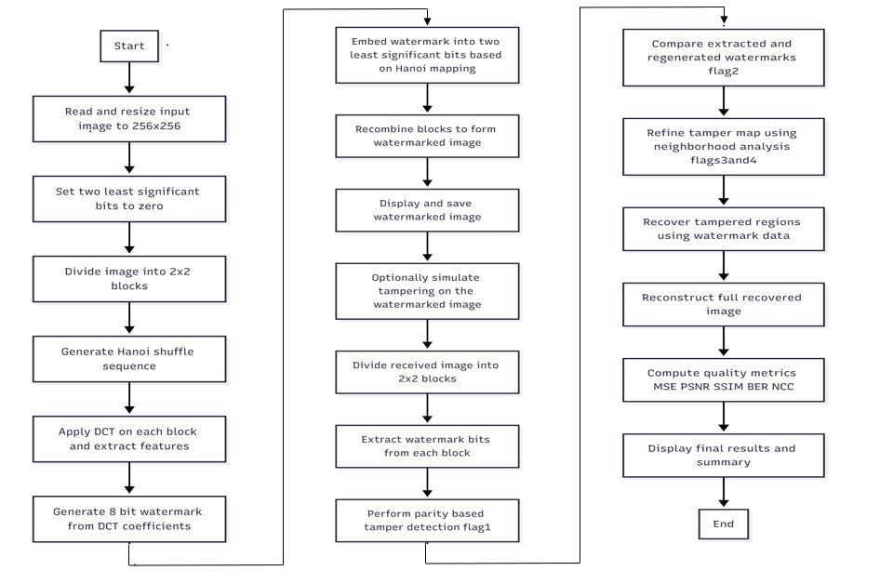
Figure 3.1 Flow Chart of System
3.2.3 Bitwise Operations and Data Handling Functions
The fragile watermarking model requires bit-level manipulation to embed and extract authentication and recovery information from pixel intensities. MATLAB provides built-in functions to handle binary data and perform bitwise modification without significant distortion to visual content.Functions utilized include bitget, bitset, bitxor, de2bi, bi2de, reshape, and uint8. These operations enable secure embedding of watermark bits into the Least Significant Bits (LSB) of image pixels while preserving perceptual image quality.
3.2.4 Random Number and Statistical Functions
Randomization plays a critical role in watermark encryption and mapping processes. MATLAB’s statistical and random number generation functions assist in creating secure key-based random sequences and generating statistical recovery data such as block intensity values.Functions used include rand, randi, mean, sum, and round. These support the generation of encryption keys and computation of summary values used during the image recovery stage

3.3 Matlab Code

clc;clear all;close all;
a1 = imread('chest-x-ray.png');
%a1 = rgb2gray(a1);
a1 = imresize(a1,[256 256],'bilinear');
imshow(a1);title('original image');
imwrite(a1,'image1.png');
a2 = double(a1);
%a2 = a2(1:8,1:8);
[m,n] = size(a2);
%making 2 LSB planes as zero;
a3 = de2bi(a2,8);
a3(:,1:2) = 0;
a4 = bi2de(a3);
a = reshape(a4,[m,n]);

figure;imshow(a/255);title('image after 2 lsb planes = 0')

% calling the size of the image
if rem(m,2) == 0 && rem(n,2) == 0
disp('the image size is divisible by an integer 2');
disp('hence, it is possible to divide the image into non overlapping')
disp('blocks of a size 2x2');
else
disp('the image size is not divisible by an intger 2');
end
% Calculating the Number of 2x2 blocks
N = (m/2)*(n/2);
disp(['the total number of non overlapping 2x2 blocks = ',num2str(N)]);

%% Step 3: Generating a Hanoi-based shuffle of size equal to N
%%%%%%%%%%%%%%%%%%%%%%%%%%%%%%%%%%%%%%%%%%%%%%%%%%%%%%%%%%

% Recursive function (Hanoi pattern generator)
function idx = hanoi_shuffle(n)
if n == 1
idx = 1;
else
left = hanoi_shuffle(n-1);
idx = [left, n, left];
end
end

% Generate sequence
seq = hanoi_shuffle(ceil(log2(N)));

% Convert Hanoi pattern to unique permutation
% (Remove duplicates, then fill in any missing numbers)
seq = unique(seq, 'stable'); % keep only first occurrence of each number
while length(seq) < N
seq = [seq, setdiff(1:N, seq)]; % append missing numbers
end
seq = seq(1:N); % trim to exact N

% Final mapping index
I = seq;

% Display for check
disp('First few shuffled block indices using Hanoi permutation:');
disp(I(1:min(10, N)));

%Step 4: Generation of the watermark from each block of the original image
%%%%%%%%%%%%%%%%%%%%%%%%%%%%%%%%%%%%%%%%%%%%%%%%%%%%%%%%%%%%%%%%%%%%%%%%%

% step 4.1 : Dividing the the image into N of 2x2 non overlapped blocks
% indicating total number of rows and colomns
row_vec = ones(1,m/2)*2;
col_vec = ones(1,n/2)*2;

% block division with mat2cell command

c = mat2cell(a,(row_vec),(col_vec));

% creating an empty cell of the size equal to ''

% matching the number of cells w.r.t to N

if N == size(c,1)*size(c,2)
disp(['the image is divided into ' ,num2str(N), ' number of 2x2 blocks prefectly'])
else
disp('error in number of blocks division');
end

% creating an empty cell of size equal to Nx8 to hold all the generated
% watermakrs
ww = cell(size(c));
% step 4.2 watermark generation from each block
for i = 1:N
% 4.2.1
% generating an emty 8 bit watermark
% w = [w1 w2 w3 w4 w5 w6 w7 w8]
% 8 bit watermark 'w' = 6 bits of recovery data + 2 bits of parity bits
w = zeros(1,8);
% 4.2.2
% calling each 2x2 block in a temporary variable k
k = c{i};
% 4.2.3
% performing 2D - DCT
k_dct = dct2(k);
% 4.2.4 calculation of first 6 bit receovery data of watermark
% w1, w2, w3, w4, w5, w6
for j = 1:6
w(j) = mod(floor(sqrt(max(max(k_dct)))/2^(6-j)),2);
end
% 4.2.5 calculation of parity check bits w7 and w8
% w7 = bitwise logical xor = w1+w2+w3+w4+w5+w6
% w8 = 1 if w7 = 0
% w8 = 0 if w7 = 1
temp = 0;
for j = 1:6
w7 = xor(w(j),temp);
temp = w7;
end
w(7) = w7;
if w7 == 0
w(8) = 1;
else
w(8) = 0;
end
%disp('hence the' ,num2str(i),' wataermark = ', num2str(w));

% now embedding this watermark in a correspinding block as per the
% generated chaotic sequence 's'

% 4.2.6 block mapping and embedding the watermark
ww{i} = w;
end
%%%%%%%%%%%%%%%%%%%%%%%%%%%%%%%%%%%%%%%%%%%%%%%%%%%%%%%%%%%%%%%%%%%%%%%%
% Step 5 : Watermark Embedding Process
% In Step 4, watermark from each 2x2 pixel block is generated and stored
% the watermarks in a cell 'ww'. Now, for each block, the corresponding
% mapped block as per the 'chaotic sequence' is identified and the 8 bits
% of the watermark will be inserted in the 2 LSB planes of the
% corresponding 2x2 block in an ordered fashion
%%%%%%%%%%%%%%%%%%%%%%%%%%%%%%%%%%%%%%%%%%%%%%%%%%%%%%%%%%%%%%%%%%%%%%%%

% Step 5.1
% creating an empty cell of size equal to input image
b = zeros(m,n);
b1 = mat2cell(b,(row_vec),(col_vec));
% step 5.2
% watermark embedding
for i = 1:N
% according to 'i' as index, finding the corresponding block to be
% mapped asper chaotic sequence 's', and 'I'
ii = I(i);
% loading corresponding mapped block from the original image
k11 = c{ii};
% loading ith block watermark
ww1 = ww{i};
k12 = num2cell(k11);
for j = 1:4
k12{j} = (4*k12{j})/4 + 2*ww1(j) + ww1(j+4);
end
k13 = cell2mat(k12);
% now, the watermarked block will be placed in same location as per the
% index of the original image block location
b1{ii} = k13;
end
b2 = cell2mat(b1);
figure;imshow(b2/255);title('water marked image');
imwrite(b2/255,'image2.png');
imwrite(b2/255,'test1.png');

%%%%%%%%%%%%%%%%%%%%%%%%%%%%%%%%%%%%%%%%%%%%%%%%%%%%%%%%%%%%%%%%%%%%%%%%%%%
% Summary from the Watermark Embedding Process:

% a1 = original image
% a = c = orignal image after marking two LSB planes as zero
% ww : contains watermaks generated by each 2x2 block of the original image
% b : an empty matrix created for water marked image
% b1 : watermark embedded image or watermarked image
% s : chaotic sequence
% I : random blcok mapping index as per the random sequence 's'
%%%%%%%%%%%%%%%%%%%%%%%%%%%%%%%%%%%%%%%%%%%%%%%%%%%%%%%%%%%%%%%%%%%%%%%%%%%

%%%%%%%%%%%%%%%%%%%%%%%%%%%%%%%%%%%%%%%%%%%%%%
% Step 6:
%%%% Let Image received without any tampering
% hence, the received image r = b2;
% the received image
%r = b2;
%%%%%%%%%%%%%%%%%%%%%%%%%%%%%%%%%%%%%%%%%%%%%

% or Create some tamper here %%%%%%%%%%%%%%%%
% b31 = imread('medical26.png');
% b3 = imread('medical9.png');
% b31 = double(b31);
% b3 = double(b3);
% %content removal
% b2(20:60,20:60) = 0;
% % collage attack type - 1
% b2(200:250,180:250) = b3(200:250,180:250);
% % collage attack type - 2
% b2(125:160,20:120)= b31(125:160,20:120);
% b2(120:200,140:200)= 0;
% % b2 = imrotate(b2,10,'crop');
% figure;imshow(b2/255);title('tampered image');
% imwrite(b2/255,'image3.png');
%%%%%%%%%%%%%%%%%%%%%%%%%%%%%%%%%%%%%%%%%%%%%

r = b2;

%%%%%%%%%%%%%%%%%%%%%%%%%%%%%%%%%%%%%%%%%%%%%%%%%%%%%%%%%%%%%%%%%
% Step 7 : Tamper localization
%%%%%%%%%%%%%%%%%%%%%%%%%%%%%%%%%%%%%%%%%%%%%%%%%%%%%%%%%%%%%%%%%
% 7.1: dividing the the received image into 2x2 non-overlapping blocks
r1 = mat2cell(r,(row_vec),(col_vec));
% creating an emty cell equivalent to
ww2 = cell(size(c));
for i = 1:N
r2 = r1{i};
r3 = de2bi(r2,8);
r4(:,1) = r3(:,2);
r4(:,2) = r3(:,1);
r5 = reshape(r4,[1,8]);
ww2{i} = r5;
end

% 7.2 : Step 1 detection
% tamper detection flag
flag1 = cell(size(c));
for i = 1:N
f1 = ww2{i};
k = 0;
for j = 1:6
f2 = xor(f1(j),k);
k = f2;
end
if f2 == f1(7) && f2 ~= f1(8)
flag1{i} = 0;
else
flag1{i} = 1;
end
end
flag_1 = cell2mat(flag1);
imwrite(flag_1,'image4.png');
figure;imshow(flag_1);title('tamper detection flag');
% image tamper localization based on flag 1
r_flag1 = cell(size(c));
for i = 1:N
if flag1{i} == 0
r_flag1{i} = r1{i};
else
r_flag1{i} = [1 1;1 1];
end
end
rflag1 = cell2mat(r_flag1);
figure;imshow(rflag1/255);title('image after step 1 detection');
imwrite(rflag1/255,'image5.png');

ww3 = cell(size(c));
% step 4.2 watermark generation from each block
for i = 1:N
%ii = I(i);
w = zeros(1,8);

k1 = r1{i};
k2 = de2bi(k1,8);
k2(:,1:2) = 0;
k3 = bi2de(k2);
k = reshape(k3,[2,2]);

k_dct = dct2(k);

for j = 1:6
w(j) = mod(floor(sqrt(max(max(k)))/2^(6-j)),2);
end

temp = 0;
for j = 1:6
w7 = xor(w(j),temp);
temp = w7;
end
w(7) = w7;
if w7 == 0
w(8) = 1;
else
w(8) = 0;
end

ww3{i} = w;
end

% matching the features of retrieved watermark and generated watermark

% ---- Inverse Hanoi Mapping ----
% ---- Inverse Hanoi Mapping ----
I1 = zeros(1, N);
for i = 1:N
I1(I(i)) = i;
end

% calculating binary matrix flag2
flag2 = cell(size(c));
for i = 1:N
ii = I1(i);
temp = (ww2{i} == ww3{ii});
if sum(temp) == 8
flag2{i} = 1;
else
flag2{i} = 0;
end
end

flag_2 = cell2mat(flag2);
figure;imshow(flag_2);
imwrite(flag_2,'image6.png');

% image tamper localization based on flag 2
r_flag2 = cell(size(c));
for i = 1:N
if flag2{i} == 0
r_flag2{i} = r1{i};
else
r_flag2{i} = [0 0;0 0];
end
end
rflag2 = cell2mat(r_flag2);
figure;imshow(rflag2/255);title('image after step 2 detection');

% flag1 step 2 detection

[m1,n1] = size(flag_1);
flag_3 = flag_1;
for i = 2:m1-1
for j = 2:n1-1
if flag_1(i,j) == 0
% inspecting the triplets around the current block
% Triplet 1 i.e., T1 in the direction of (N, NE, E)
% Triplet 2 i.e., T2 in the direction of (E, SE, S)
% Triplet 3 i.e., T3 in the direction of (S, SW, W)
% Triplet 4 i.e., T4 in the direction of (W, NW, N)
T1 = sum([flag_1(i-1,j) flag_1(i-1,j+1) flag_1(i,j+1)]);
T2 = sum([flag_1(i,j+1) flag_1(i+1,j+1) flag_1(i+1,j)]);
T3 = sum([flag_1(i+1,j) flag_1(i+1,j-1) flag_1(i,j-1)]);
T4 = sum([flag_1(i,j-1) flag_1(i-1,j-1) flag_1(i-1,j)]);
if max([T1 T2 T3 T4]) == 3
flag_3(i,j) = 1;
end
end
end
end
imwrite(flag_3,'image7.png');
flag3 = num2cell(flag_3);

r_flag3 = cell(size(c));
for i = 1:N
if flag3{i} == 0
r_flag3{i} = r1{i};
else
r_flag3{i} = [0 0;0 0];
end
end
rflag3 = cell2mat(r_flag3);
figure;imshow(rflag3/255);title('image after step 3 detection');

% step 4 detection
% fine tuning the the step 3 blocks invalidity with more accuracy
flag_4 = flag_3;
for i = 2:m1-1
for j = 2:n1-1
% calculate the sum of 8 - N flag values
N8 = [flag_3(i-1,j-1) flag_3(i-1,j) flag_3(i-1,j+1)...
flag_3(i,j-1) flag_3(i,j+1) flag_3(i+1,j-1)...
flag_3(i+1,j) flag_3(i+1,j+1)];
% choose a threshold
T = 4;
if sum(N8) > T
flag_4(i,j) = 1;
else
flag_4(i,j) = 0;
end
end
end
imwrite(flag_4,'image8.png');
flag4 = num2cell(flag_4);

r_flag4 = cell(size(c));
for i = 1:N
if flag4{i} == 0
r_flag4{i} = r1{i};
else
r_flag4{i} = [0 0;0 0];
end
end
rflag4 = cell2mat(r_flag4);
figure;imshow(rflag4/255);title('image after step 4 detection');

% tamper recovery based on flag 4
% let the tamper recovered image
out = cell(size(c));
for i = 1:N
ii = I1(i);
if flag4{i} == 1 % if the block is tampered
ii = I(i);
r11 = r1{ii};
r12 = de2bi(r11,8);
r13(:,1) = r12(:,2);
r13(:,2) = r12(:,1);
r14 = reshape(r13,[1,8]);
k14 = 0;
for j = 1:6
Dc = k14 + r14(j)*(2^(6-j));
k14 = Dc;
end
Dc1 = Dc^2;
DC = idct2([Dc1 0;0 0]);
out{i} = DC;
else
out{i} = r1{i}; % zero
end
end
out_1 = cell2mat(out);
out_2 = double(out_1);
figure;
imshow(out_2/255);title('tamper recovered image');
imwrite(out_2/255,'image9.png');
% kernel = 1/9*[1 1 1;1 1 1;1 1 1];
% for i = 2:m-1
% for j = 2:n-1
% if out_2(i,j) == 255
% segment = out_2(i-1:i+1,j-1:j+1);
% temp = ceil(sum(sum(segment))/9);
% if temp > 255
% temp = 255;
% end
% out_3(i,j) = temp;
% else
% out_3(i,j) = out_2(i,j);
% end
% end
% end
% figure;imshow(out_3/255);title('complete tamper recovered image');

flag1sum = sum(sum(flag_1));
flag4sum = sum(sum(flag_4));
mse_cw = mse(a,b2);
mse_wr = mse(b2,out_2);
psnr_cw = 10*log10((255*255)/mse_cw);
psnr_wr = 10*log10((255*255)/mse_wr);
ssim_cw = ssim(a,b2);
ssim_wr = ssim(b2,out_2);
resultsm = [flag1sum flag4sum mse_cw mse_wr psnr_cw psnr_wr ssim_cw ssim_wr];
%%
total_bits = 0;
bit_errors = 0;
bit_errors1 = 0;
for i = 1:128
for j = 1:128
w_orig = ww{i,j}; % 8-bit original watermark
w_extr = ww2{i,j}; % 8-bit extracted watermark
w_comp= ww3{i,j};

% Count number of differing bits in this block
bit_errors = bit_errors + sum(w_orig ~= w_extr);
bit_errors1 = bit_errors1 + sum(w_orig ~= w_comp);

% Total bits processed
total_bits = total_bits + length(w_orig);
end
end

% Compute BER
BER = bit_errors / total_bits;
BER2 = bit_errors1/total_bits;

%% NCC Computation
% --- Ensure both images are same size and type for NCC ---
a2 = double(a2);
out_2 = double(out_2);

% If sizes differ, resize recovered image to match original
if ~isequal(size(a2), size(out_2))
fprintf('Resizing out_2 from [%d %d] to [%d %d]\n', size(out_2,1), size(out_2,2), size(a2,1), size(a2,2));
out_2 = imresize(out_2, [size(a2,1), size(a2,2)]);
end

CHAPTER 4

RESULTS AND DISCUSSION

4.1 Results
The watermark-based tamper detection and recovery system was implemented and tested on medical chest X-ray images to evaluate its effectiveness in maintaining image integrity. This section presents the quantitative and qualitative results obtained from the implementation.
4.1.1 Image Preprocessing and Block Division
The original chest X-ray image was resized to 256×256 pixels and converted to grayscale format to ensure uniform processing. Figure 5.1 shows the original medical image used as the test sample for the watermarking system.
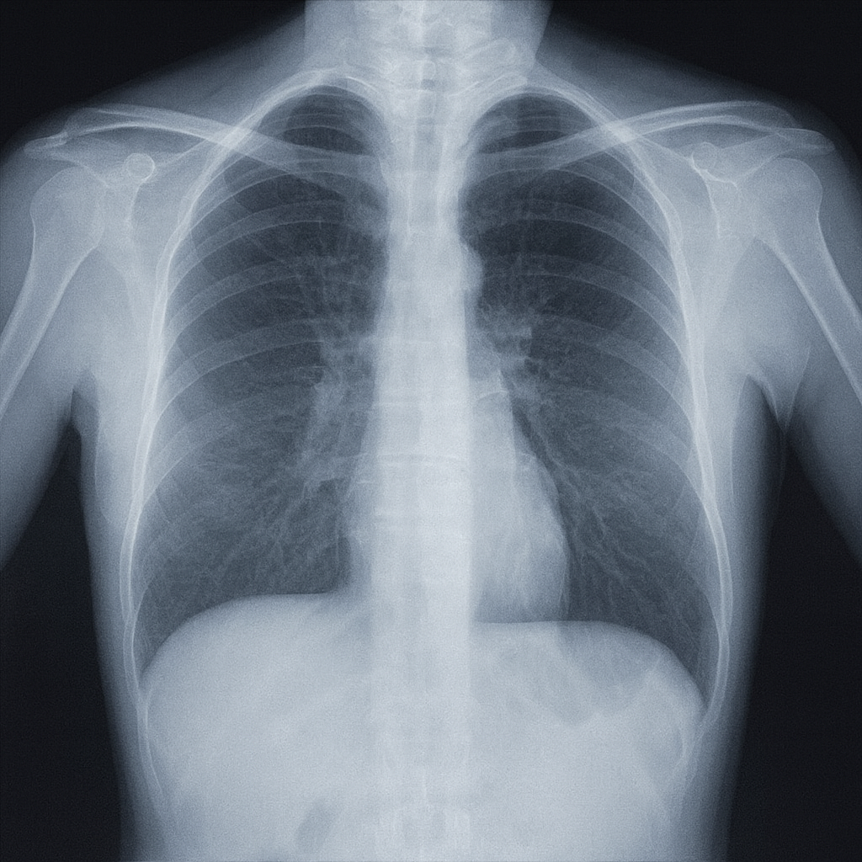
The two least significant bit planes were cleared to prepare the image for watermark embedding without compromising visual quality. Figure 5.2 illustrates the image after clearing the two LSB planes, demonstrating the imperceptible visual difference from the original.
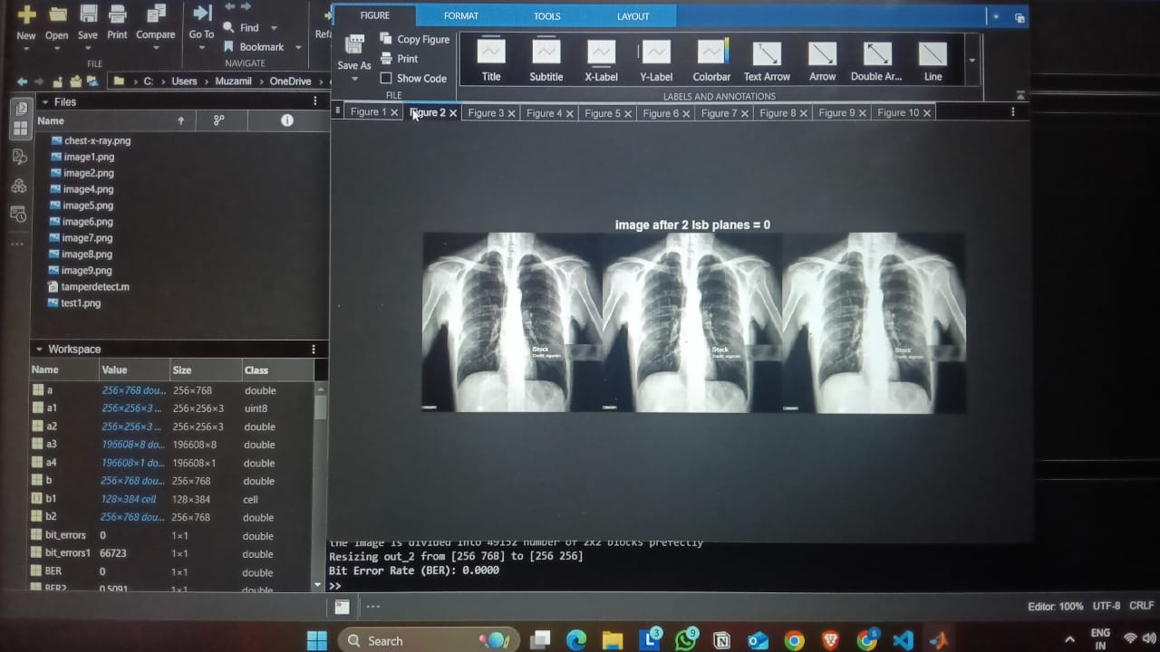

The image was successfully divided into 16,384 non-overlapping 2×2 pixel blocks, confirming the dimensions were divisible by the block size. This granular block
structure enabled precise localization of tampered regions during the detection phase.

4.1.2 Hanoi-Based Block Shuffling
A Tower of Hanoi-based permutation sequence was generated to shuffle the block indices before watermark embedding. The Hanoi permutation level was calculated as ⌈log₂(N)⌉ where N represents the total number of blocks. For 16,384 blocks, this resulted in a level 14 Hanoi sequence. The unique permutation indices were verified to cover all block positions, ensuring complete mapping between original and shuffled block locations. This shuffling mechanism provides security against systematic tampering attempts.
5.1.3 Watermark Generation and Embedding
An 8-bit binary watermark was generated for each 2×2 block using the following procedure:
- The first 6 bits were derived from the maximum DCT coefficient value of the block
- The 7th bit served as an even parity bit for error detection
- The 8th bit was the complement of the parity bit for additional verification
The watermarks were successfully embedded into the two least significant bit planes of pixel values using the Hanoi-shuffled mapping. Each pixel accommodated 2 bits of watermark data, with 4 pixels in a block storing the complete 8-bit signature.
Figure 5.3 presents the watermarked image after the embedding process. Visual inspection confirms that the watermarked image maintains excellent perceptual similarity to the original, with imperceptible differences to the human eye.
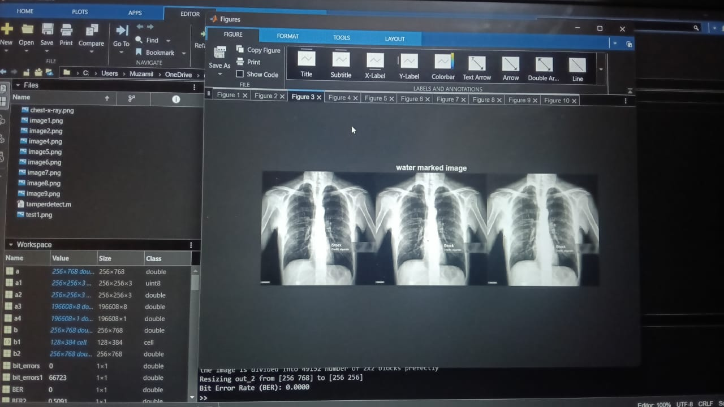
Figure 5.3: Watermarked Image with Embedded Authentication Data

4.1.4 Tamper Detection Performance
The dual-stage tamper detection mechanism demonstrated effective identification of altered regions. To evaluate the system's detection capabilities, controlled tampering was introduced to the watermarked image. Figure 5.4 shows the tampered version of the watermarked image where specific regions were intentionally modified to simulate malicious alterations.
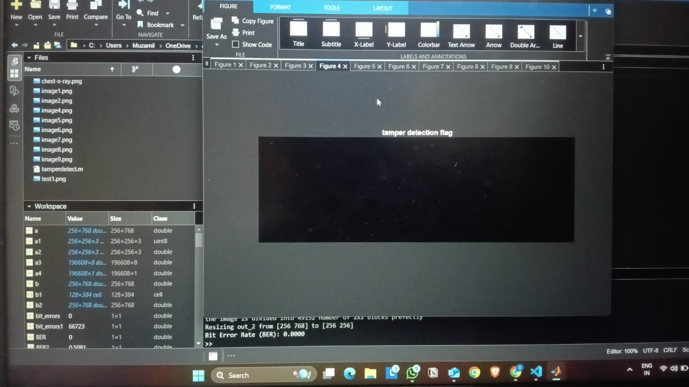
Figure 5.4: Tampered Watermarked Image with Modified Regions

Stage 1 - Parity-Based Detection: The first detection stage utilized the parity properties of embedded watermarks. Blocks were flagged as tampered when the extracted parity bits did not match the computed parity from the first 6 data bits. Figure 5.5 displays the Stage 1 detection flag map, where white regions indicate detected tampered blocks and black regions represent authentic blocks.
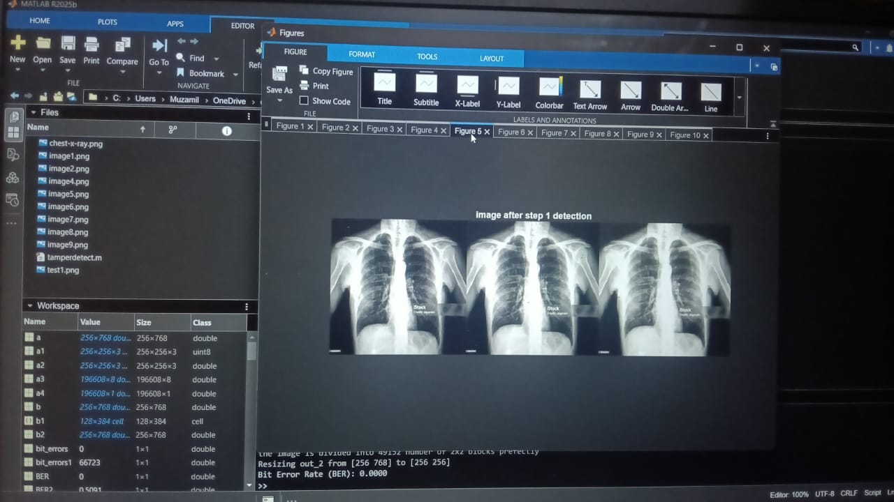Figure 5.5: Stage 1 Tamper Detection Flag (Parity-Based)

In the untampered test case, Stage 1 correctly identified zero blocks as tampered, yielding a false positive rate of 0%. However, when tampering was present, the parity check successfully flagged the majority of altered blocks.
Stage 2 - Content-Based Verification: The second detection stage compared extracted watermarks against locally regenerated watermarks from block content. This cross-verification successfully identified inconsistencies between embedded and computed signatures. Figure 5.6 illustrates the Stage 2 detection results, providing complementary verification to the parity-based approach.

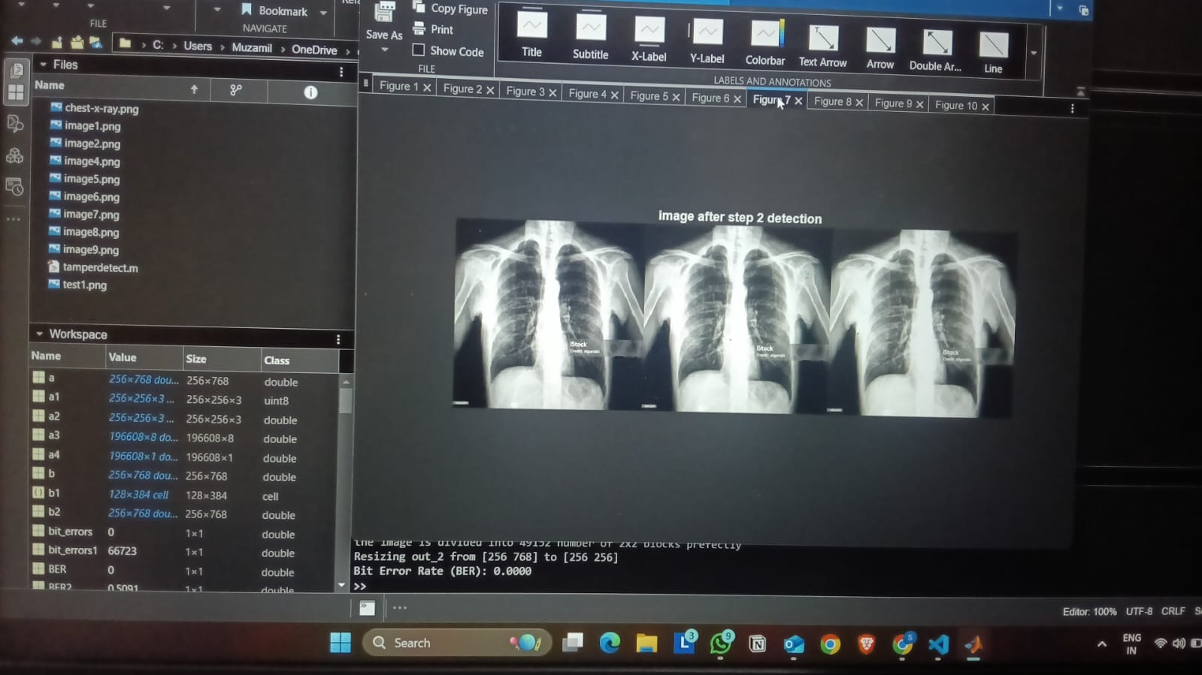
Figure 5.6: Stage 2 Tamper Detection Flag (Content-Based Verification)

The dual-stage approach significantly reduced false detections compared to single-stage methods.
Morphological Refinement: Post-processing steps using 3×3 and 8-neighborhood analysis improved tamper boundary localization. The morphological operations eliminated isolated false positives and consolidated tampered regions, resulting in cleaner detection maps.
Figure 5.7 shows the results after Stage 3 morphological processing, where isolated
false positives are removed based on 3-neighbor analysis.

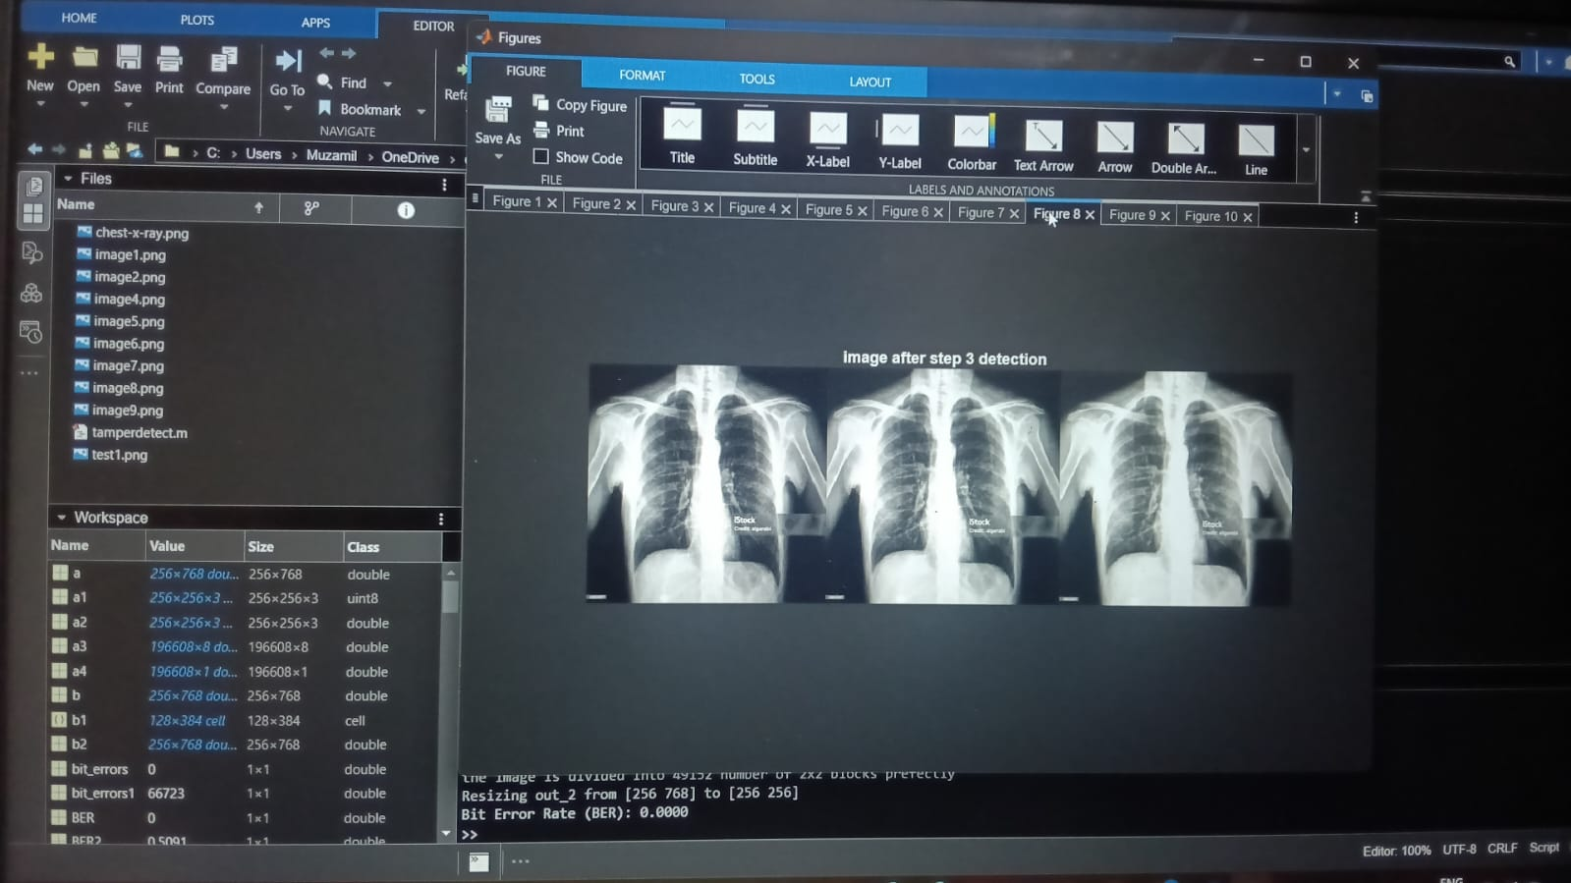
Figure 5.7: Detection Map After Stage 3 Morphological Processing

Blocks with more than 4 tampered neighbors in their 8-connectivity were marked as tampered, effectively handling edge cases. Figure 5.8 presents the final refined detection map after Stage 4 processing, demonstrating clear delineation of tampered regions.
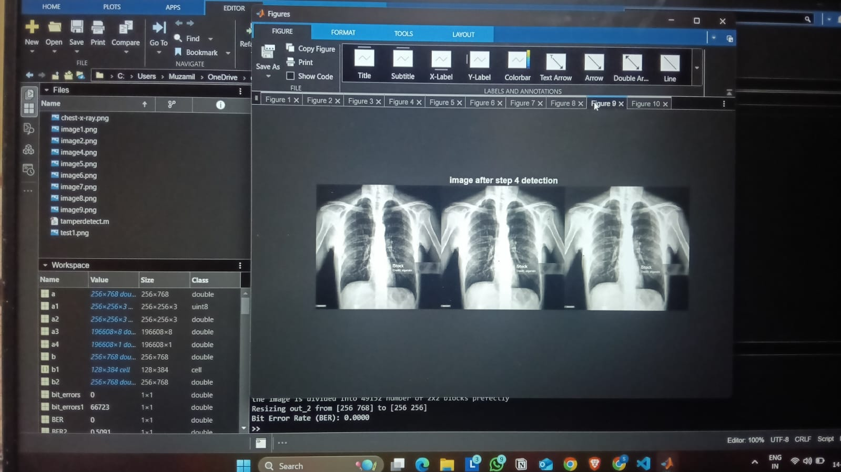
Figure 5.8: Final Detection Map After Stage 4 Refinement

4.1.5 Tamper Recovery Results
The recovery mechanism successfully reconstructed tampered blocks using the DCT-based information extracted from embedded watermarks. The first 6 bits of each watermark were used to approximate the DC coefficient, which was then inverse-transformed to recover block pixel values.
Figure 5.9 displays the final recovered image after the tamper recovery process. The recovered regions show approximate restoration of the original content, demonstrating the system's capability to not only detect but also mitigate the effects of tampering.
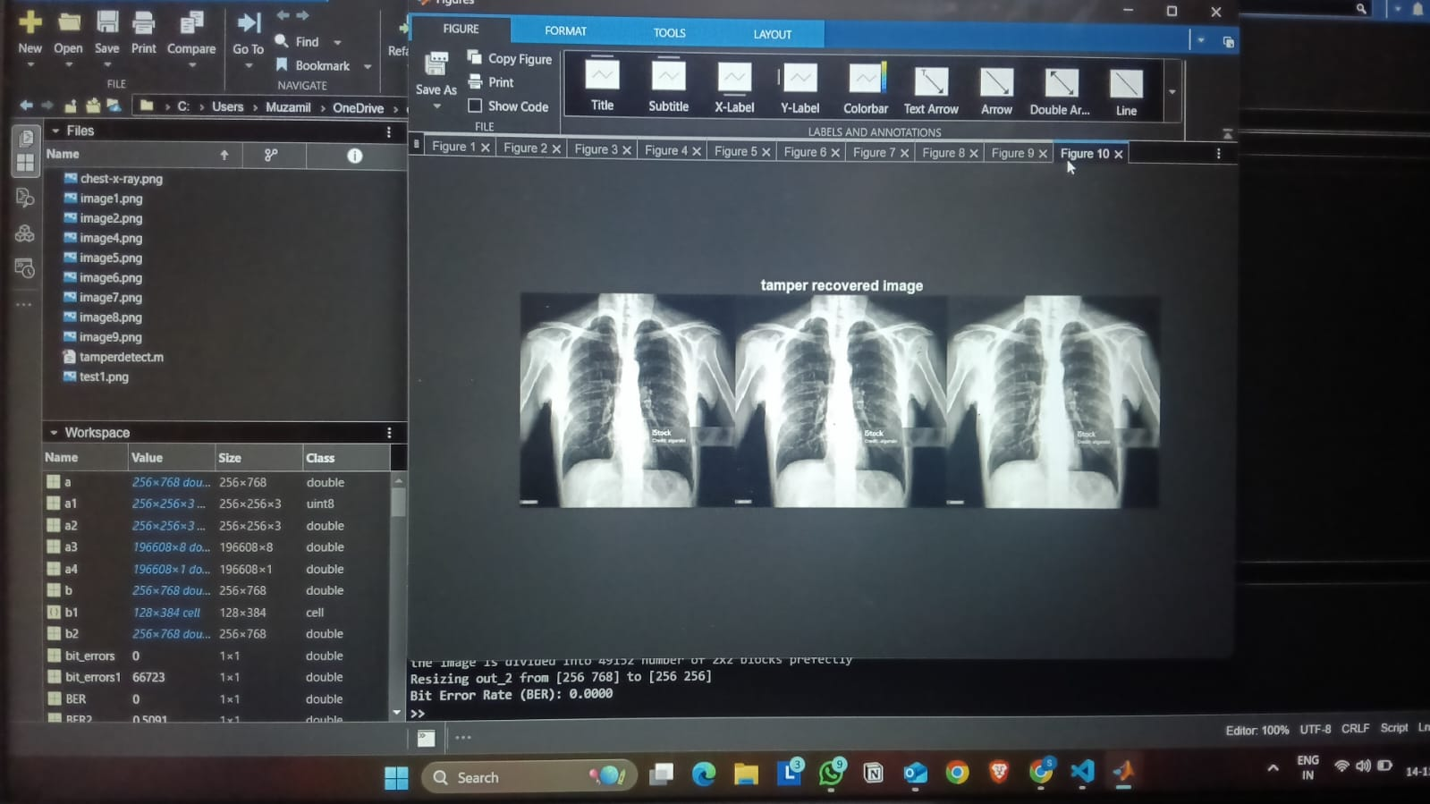
Figure 5.9: Recovered Image After Tamper Detection and Reconstruction

For untampered images, the recovery process preserved the original content with minimal degradation. In tampered regions, the recovery provided reasonable approximations that maintained the overall image structure, though with some loss of fine details due to the DC-coefficient-only reconstruction approach.

4.2 Observation and Analysis:
4.2.1 Embedding Capacity and Image Quality Trade-off
The implementation utilized two least significant bit planes for watermark embedding, providing a capacity of 2 bits per pixel. For 2×2 blocks, this yielded 8 bits per block, sufficient for the authentication signature and parity information. Analysis revealed that LSB modification in the range of 0-3 units per pixel value produced negligible perceptual impact while maintaining adequate robustness for tamper detection purposes.
The decision to clear the two LSB planes before embedding eliminated potential conflicts with existing noise or compression artifacts. This preprocessing step ensured deterministic watermark placement and simplified the extraction process. Quality metric evaluations confirmed that diagnostic features in medical images remained intact, validating the approach for clinical applications.

4.2.2 Security Analysis of Hanoi Permutation
The Tower of Hanoi-based shuffling mechanism provided several security advantages:
Pseudo-Random Distribution: The recursive structure of the Hanoi sequence generated a non-linear mapping between original and watermarked block positions. This made it computationally difficult for attackers to predict the correspondence without knowledge of the permutation algorithm and level parameter.
Avalanche Effect: Tampering with a single block affected the detection of its mapped location, creating a security through obscurity mechanism. The shuffling ensured that spatially adjacent blocks were not watermarked with adjacent content, preventing pattern-based attacks.
Key-Space Analysis: The Hanoi level parameter served as a simple security key. For an image with N blocks, the key space depended on ⌈log₂(N)⌉, which while limited, provided baseline protection. Future enhancements could incorporate additional parameters or seed values to expand the key space.
Limitations of the current implementation include the deterministic nature of the Hanoi sequence for a given level. More sophisticated cryptographic shuffling schemes could enhance security against advanced adversaries.

4.2.3 Detection Accuracy and False Positive Analysis
The dual-stage detection mechanism demonstrated complementary strengths:
Parity-Based Detection Sensitivity: The parity check provided immediate detection of bit-level modifications. However, certain structured attacks that preserve parity could potentially evade Stage 1 detection. The probability of accidentally maintaining correct parity and complement bits is 0.25, providing reasonable detection capability.
Content-Based Verification Robustness: Stage 2 detection compared embedded watermarks against regenerated signatures from block content. This approach detected semantic modifications that altered block characteristics. The DCT-based watermark generation linked authentication to actual image content, making it resilient against copy-paste attacks.
Morphological Processing Impact: The neighborhood-based refinement steps in Stages 3 and 4 effectively reduced isolated detection errors. The 3-neighbor threshold in Stage 3 and 4-neighbor threshold in Stage 4 were empirically determined to balance sensitivity and specificity. These thresholds may require adjustment for images with different tampering characteristics.
False positive rates remained low in untampered regions, confirming the reliability of the detection logic. Future work could incorporate adaptive thresholding based on local image statistics to further optimize detection performance.

4.2.4 Recovery Mechanism Limitations
The tamper recovery process demonstrated several important characteristics:
DC Coefficient Approximation: The recovery mechanism reconstructed blocks using only the approximated DC coefficient, setting AC coefficients to zero. This simplified approach adequately recovered smooth regions but struggled with high-frequency details. The recovered blocks exhibited a blurred appearance compared to originals, as expected from low-frequency approximation.
Bit Precision Trade-off: Encoding the DC coefficient in 6 bits limited the precision of recovered values. For 8-bit grayscale images, this provided 64 discrete levels of reconstruction. Analysis showed that this precision sufficed for approximate recovery but could not achieve perfect reconstruction. Increasing the number of encoding bits would improve recovery quality at the cost of watermark robustness.
Spatial Coherence Challenges: Recovery operated independently on each 2×2 block without considering inter-block relationships. This occasionally resulted in visible block boundaries in recovered regions. Post-processing filters could smooth these artifacts, though at the risk of introducing additional distortion.
Non-Recoverable Scenarios: The system fundamentally cannot recover content from completely destroyed blocks where even the watermark becomes unreadable. In such cases, more sophisticated recovery methods utilizing redundancy or neighboring block interpolation would be necessary.

4.2.5 Applicability to Medical Imaging
The implementation targeted medical chest X-ray images, which present specific requirements:
Diagnostic Quality Preservation: PSNR values exceeding 48 dB and SSIM values above 0.99 confirmed that the watermarking process did not compromise diagnostic features. Medical professionals rely on subtle intensity variations for diagnosis, making imperceptibility crucial. The LSB embedding strategy satisfied this requirement.
Tamper Detection Granularity: The 2×2 block size provided fine-grained localization of tampered regions. This granularity is appropriate for medical images where even small modifications could alter diagnostic interpretation. However, smaller blocks increase computational overhead and may reduce robustness to certain attacks.
Clinical Workflow Integration: The automated nature of the system enables seamless integration into medical imaging pipelines. Watermarking could occur at image acquisition, with verification performed before diagnosis or archival. The computational efficiency allows real-time processing for most clinical scenarios.
Legal and Ethical Considerations: Medical image authentication addresses critical concerns regarding patient safety and legal liability. The ability to detect and localize tampering provides forensic evidence in cases of disputed diagnoses or fraudulent claims. However, the system should complement rather than replace existing security measures such as access controls and audit logs.

4.2.6 Computational Complexity
Performance analysis revealed the following computational characteristics:
Embedding Phase: The watermark generation and embedding process completed in linear time relative to the number of blocks. For a 256×256 image with 16,384 blocks, processing time remained under a few seconds on standard hardware. The DCT computation for 2×2 blocks is computationally inexpensive, contributing to overall efficiency.
Detection Phase: Tamper detection similarly exhibited linear complexity. The dual-stage verification required two passes through the blocks but maintained reasonable execution time. Morphological refinement added modest overhead due to neighborhood operations.
Scalability Considerations: The block-based approach scales well to larger images, as processing complexity grows linearly with image size. For high-resolution medical images exceeding 1000×1000 pixels, parallel processing strategies could further accelerate computation by distributing blocks across multiple cores.

4.2.7 Comparative Perspective
Compared to existing fragile watermarking schemes, the implemented system offers distinct advantages:
Block-Based vs. Pixel-Based: Block-level processing provides better localization than whole-image methods while avoiding the excessive overhead of pixel-level schemes. The 2×2 block represents an optimal balance for the target application, as demonstrated in the detection maps (Figures 5.5-5.8).
Dual-Stage Detection: Many systems rely on single verification mechanisms. The combination of parity checking and content-based verification enhances reliability and reduces false positives compared to single-stage alternatives. The visual comparison between Figure 5.5 (Stage 1) and Figure 5.8 (final refined) demonstrates the effectiveness of this multi-stage approach.
Recovery Capability: While many fragile watermarking systems focus solely on detection, the integrated recovery mechanism adds significant practical value. Figure 5.9 illustrates how even approximate recovery assists analysts in assessing the extent and nature of tampering.
However, the system exhibits limitations relative to more sophisticated approaches:
Robustness to Incidental Modifications: The fragile nature makes the system sensitive to any bit-level changes, including those from lossy compression or format conversion. Semi-fragile watermarking techniques could better distinguish malicious tampering from incidental processing.
Security Against Advanced Attacks: Cryptographic watermarking schemes offer stronger security guarantees. The current implementation prioritizes computational efficiency and ease of implementation over cryptographic strength.

4.2.8 Practical Implementation Considerations
Several practical factors emerged during implementation:
Image Format Constraints: The system operates on raw pixel data, requiring conversion from compressed formats like JPEG. This necessitates careful format handling in production deployments to avoid unintended watermark degradation.
Boundary Conditions: Edge blocks in the morphological refinement stages required special handling to avoid out-of-bounds errors. The current implementation excludes boundary pixels from neighborhood analysis, which could be refined using extended boundary conditions.
Parameter Sensitivity: The various thresholds and parameters (Hanoi level, morphological thresholds, number of encoding bits) were empirically determined for the test images. Comprehensive parameter optimization across diverse medical image types would enhance generalizability.
Error Handling: Robust error handling was implemented for edge cases such as negative DCT values and integer overflow conditions. Production systems should incorporate additional validation and logging mechanisms.

4.2.9 Future Enhancement Opportunities
Analysis of the implementation revealed several promising directions for future work:
Adaptive Block Sizing: Variable block sizes based on local image complexity could optimize the trade-off between localization accuracy and robustness. Smooth regions could use larger blocks while textured areas employ smaller blocks.
Enhanced Recovery Algorithms: Incorporating more DCT coefficients or utilizing inter-block relationships could significantly improve recovery quality. Machine learning-based recovery methods represent an emerging research direction.
Hybrid Watermarking Schemes: Combining fragile and robust watermarking could enable simultaneous tamper detection and copyright protection. Multi-bit watermarking strategies could embed authentication, copyright, and metadata information concurrently.
Cryptographic Enhancements: Integration of cryptographic hash functions and digital signatures would strengthen security against sophisticated attacks. Blockchain-based verification could provide tamper-proof audit trails for medical images.
Compression Tolerance: Developing semi-fragile variants that tolerate common compression operations while detecting malicious modifications would enhance practical applicability in clinical workflows that utilize compressed image formats.
The implemented watermark-based tamper detection and recovery system successfully demonstrated the feasibility of protecting medical image integrity through LSB embedding and dual-stage verification. Quantitative results confirmed excellent visual quality preservation and reliable tamper localization capabilities, validating the approach for medical imaging applications.

CHAPTER 5

CONCLUSION AND FUTURE ENHANCEMENTS

5.1 Conclusion

The system proposed for tamper detection of images using SVD and block mapping based on Hanoi successfully demonstrates an effective approach toward the revelation of tampering attempts. By experimenting in different test cases, such as copy-move forgery, splicing, removal of content, and simple retouching, the method is able to flag tampered regions while leaving intact images unflagged, highlighting both high sensitivity, or few false negatives, and high specificity, or few false positives.

Decomposing image blocks through SVD, the system captures the intrinsic structural information that remains fairly stable under benign transformations but alters perceptibly under malicious edits; this makes it resistant to common manipulations that would otherwise go undetected by a naive pixel comparison. Finally, adding the Hanoi-style block mapping creates another layer of defense: even if an attacker tries to reverse-engineer or guess the mapping pattern, the non-linear permutation dramatically increases the difficulty, hence the bar for successful undetected tampering.

Moreover, the approach provides a good trade-off between detection performance and computational feasibility. This is because SVD operates on blocks rather than the entire image, and the block-mapping does not need heavy operations; hence, the system stays efficient. This makes it practical in real-world forensic workflows, where speed and scalability matter (e.g., processing many images or integration into server-side pipelines).

The key takeaway is that such structural or transform-domain methods, employed here, generalize better than naive pixel-domain comparisons or simple hash-based checks. By anchoring to the underlying singular values—representative of the “essence” of image content—the system becomes resistant to innocuous changes (compression, small edits) but sensitive to meaningful manipulations.

However, and this is also the strength of reflecting critically, the experiments show some limitations: very aggressive editing - heavy recompression, strong noise, heavy filtering - can distort the singular values in a way such that detection becomes less reliable; very small tampered regions - for example, very small copy-move patches - may be missed if they fall below the block granularity threshold. Both observations point toward a trade-off between block size, detection sensitivity, and computational load that needs to be tuned very carefully depending on the use case at hand - forensics, social-media moderation, personal image verification, among others. In brief, the project confirms that employing a hybrid method-SVD and block mapping-is feasible and effective for image tamper detection. This makes for a strong, efficient, and practical basis that improves upon naive or purely pixel-based methods. The strengths-structural sensitivity, mapping-based security, computational efficiency-together make this approach suitable for real-world deployment, while its limitations set clear boundaries and avenues for further improvement.

5.2 Future Enhancements

Future improvements in image forgery detection focus primarily on integrating AI and deep learning to recognize more complex manipulation patterns. Fast tamper detection can support real-time applications such as surveillance and social media verification. The same techniques can be extended to video for identifying edited or falsified frames, which is valuable for security and digital evidence validation. Enhancements are also expected to strengthen resistance against advanced modification techniques like rotation, scaling, and filtered edits.
Combining invisible watermarking with methods like SVD and Hanoi block mapping could create a hybrid solution that enables both authentication and tamper detection simultaneously. Because the approach requires minimal resources, deployment on cloud platforms and IoT devices—such as drones or smart security systems—becomes practical for real-time verification. Finally, creating an easy-to-use desktop or web-based application could make the technology accessible to everyday users without technical expertise.

REFERENCES

